Connor Simms

Dr. Rapp

CIS 112

Final Project READ ME

Description of the purpose/classification of the database

The purpose of this database is to serve its users with a collection of information related to the Star Wars film franchise. It stores data about the various aspects of the Star Wars Universe including , movies, characters, directors, filming locations, planets, species, vehicles, and cast members. This database acts as an online source for users to gather information based of the films in the franchise. This could be a good resource if you are an avid fan or are a researcher of the franchise. This database can be comparable to internet sources such as fandom or IMDb. I constructed this database for Star wars fans to have a place to store common information across the franchise to have proper data distribution among common interests within the films.

User Personas

1. Sarah Smith
   1. Age 34
   2. Film Researcher
   3. Interested in analyzing Star Wars movies in the franchise and conducting research on several aspects of the making and content of the film.
2. Alex Chapman
   1. Age 25
   2. Computer Science student
   3. Looking into database management. Seeking to oversee databases to ensure the reliability and performance of various databases. Would perform queries to maintain data integrity.
3. Trent Harper
   1. Age 11
   2. Average Young Fan
   3. Just watched his first starwars movie and wants to fact check information and expand his learning on the movies in the franchise. Would navigate the database to find information that interests him.

Use Case Diagram

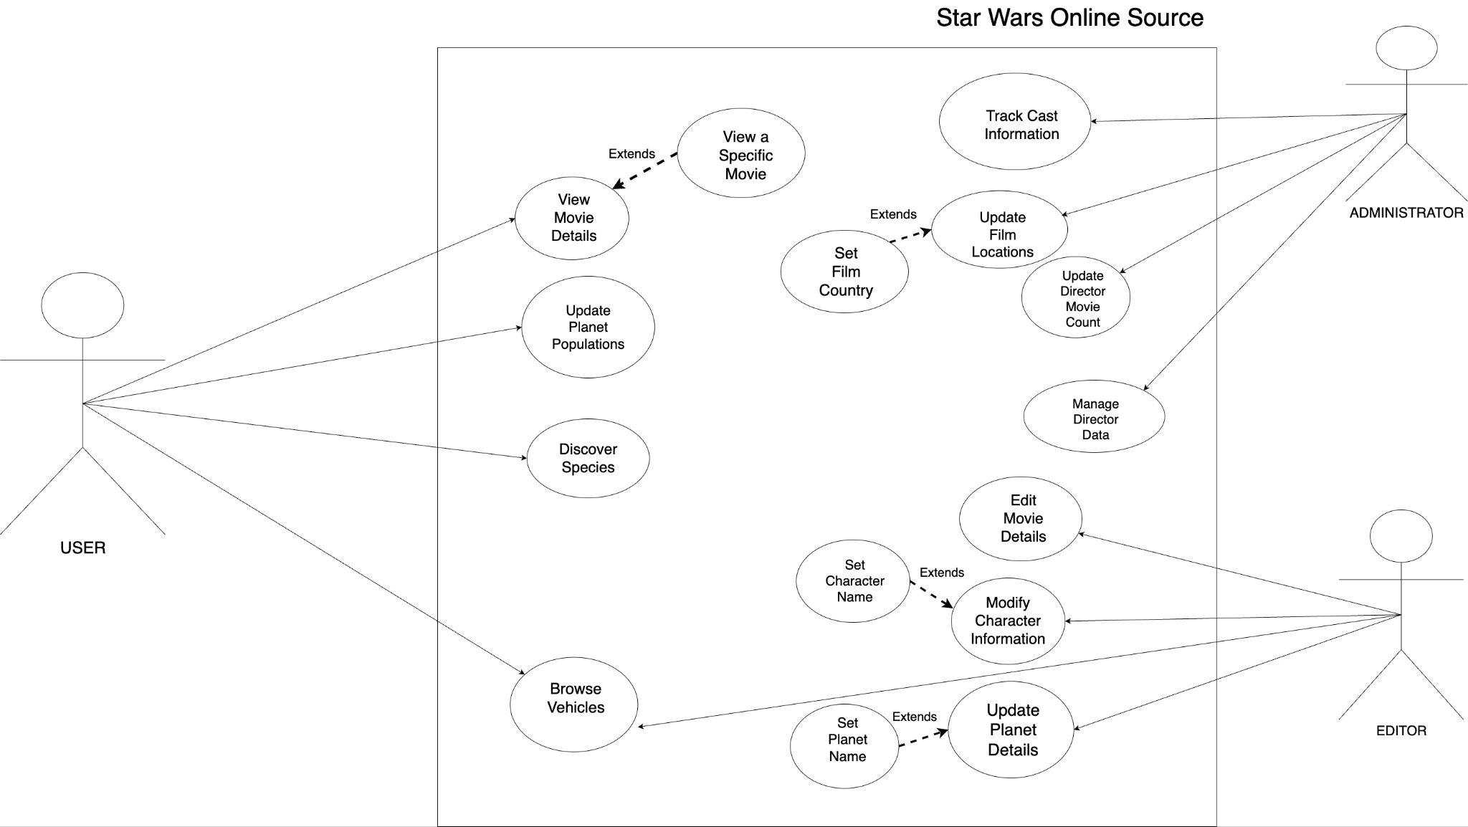

Data Dictionary

| TABLE | COLUMN | DEFINITION | TYPES | UNITS | CONSTRAINTS |
| --- | --- | --- | --- | --- | --- |
| DIRECTORS | directorId | Unique identifier for each director | TEXT | N/A | Primary Key |
| DIRECTORS | college | The college from which the director attended | TEXT | N/A | N/A |
| DIRECTORS | isMale | Indicates whether the director is male or not | BOOLEAN | N/A | N/A |
| DIRECTORS | dob | Date of birth of the director | DATE | N/A | N/A |
| DIRECTORS | dod | Date of death of the director | DATE | N/A | May be NULL |
| FILM_LOCATIONS | name | The name of the film location | TEXT | N/A | Primary Key |
| FILM_LOCATIONS | state | The state where the film location is located | TEXT | N/A | May be NULL |
| FILM_LOCATIONS | country | The country where the film location is located | TEXT | N/A | N/A |
| PLANETS | name | The name of the planet | INTEGER | N/A | N/A |
| PLANETS | climate | Description of the climate on the planet | TEXT | N/A | N/A |
| PLANETS | terrain | Description of the terrain on the planet | TEXT | N/A | N/A |
| PLANETS | population | The population count of the planet | INTEGER | N/A | May be NULL |
| PLANETS | filmedAt | The name of the film location where scenes on the planet were filmed | TEXT | N/A | N/A |
| TITLES | title | The title of the film | TEXT | N/A | N/A |
| TITLES | director | The director of the film | TEXT | N/A | N/A |
| TITLES | planet | The planet where the title was filmed | TEXT | N/A | N/A |
| TITLES | releaseYear | The year when the film was released | INTEGER | years | N/A |
| TITLES | length | The duration of the title in minutes | INTEGER | minutes | N/A |
| TITLES | episode | The episode number of the title in the series | TEXT | N/A | N/A |
| TITLES | cost | The cost of producing the title | FLOAT | millions | Must be greater than 0 |
| CAST | role | The character’s role or name in the film | TEXT | N/A | N/A |
| CAST | fn | First name of the cast member | TEXT | N/A | N/A |
| CAST | mn | Middle name of the cast member | TEXT | N/A | May be NULL |
| CAST | ln | Last name of the cast member | TEXT | N/A | N/A |
| CAST | suff | Suffix of the cast member | TEXT | N/A | May be NULL |
| CAST | dob | Date of birth of the cast member | DATE | N/A | N/A |
| CAST | dod | Date of death of the cast member | DATE | N/A | May be NULL |
| CAST | birthCity | The city where the cast member was born | TEXT | N/A | N/A |
| CAST | birthState | The state where the cast member was born | TEXT | N/A | May be NULL |
| CAST | birthCountry | The country where the cast member was born | TEXT | N/A | N/A |
| CAST | isMale | Indicates whether the cast member is male or not | BOOLEAN | N/A | N/A |
| CAST | college | The college attended by the cast member | TEXT | N/A | May be NULL |
| CAST | major | The major or field of study of the cast member | TEXT | N/A | May be NULL |
| CAST | gradSchool | Indicate whether the cast member attended graduate school | BOOLEAN | N/A | May be NULL |
| SPECIES | speciesId | Unique identifier for each species | TEXT | N/A | N/A |
| SPECIES | classification | Classification or type of the species | TEXT | N/A | N/A |
| SPECIES | language | The language spoken by the species | TEXT | N/A | N/A |
| SPECIES | lifespan | The average lifespan of the species | INTEGER | years | May be NULL |
| SPECIES | homeworld | The planet where the species is located | TEXT | N/A | May be NULL |
| SPECIES | description | Description of the species | TEXT | N/A | N/A |
| VEHICLES | vehicleId | Unique identifier for each vehicle | TEXT | N/A | N/A |
| VEHICLES | movie | The movie in which the vehicle appears | TEXT | N/A | N/A |
| VEHICLES | owner | The character who owns or uses the vehicle | TEXT | N/A | N/A |
| VEHICLES | capacity | The maximum number of passengers the vehicle can carry | INTEGER | Number of people | N/A |
| VEHICLES | weight | The weight of the vehicle in pounds | FLOAT | lbs | Must be greater than 0 |
| VEHICLES | maxSpeed | The maximum speed of the vehicle in miles per hour | FLOAT | mph | Must be greater than 0 |
| VEHICLES | manufacturer | The company that manufactured the vehicle | TEXT | N/A | May be NULL |
| VEHICLES | price | The price of the vehicles in Star Wars credits | FLOAT | Starwars credits | Must be greater than 0 |
| CHARACTERS | name | The name of the character | TEXT | N/A | N/A |
| CHARACTERS | species | The species to which the character belongs | TEXT | N/A | N/A |
| CHARACTERS | movie | The movie in which the character appears | TEXT | N/A | N/A |
| CHARACTERS | vehicleUsed | The vehicle used by the character | TEXT | N/A | May be NULL |
| CHARACTERS | height | The height of the character in feet | FLOAT | Number left of decimal is feet and left is inches | N/A |
| CHARACTERS | weight | The weight of the character in pounds | FLOAT | lbs | Must be greater than 0 |
| CHARACTERS | gender | The gender of the character | TEXT | N/A | May be NULL |

ERD

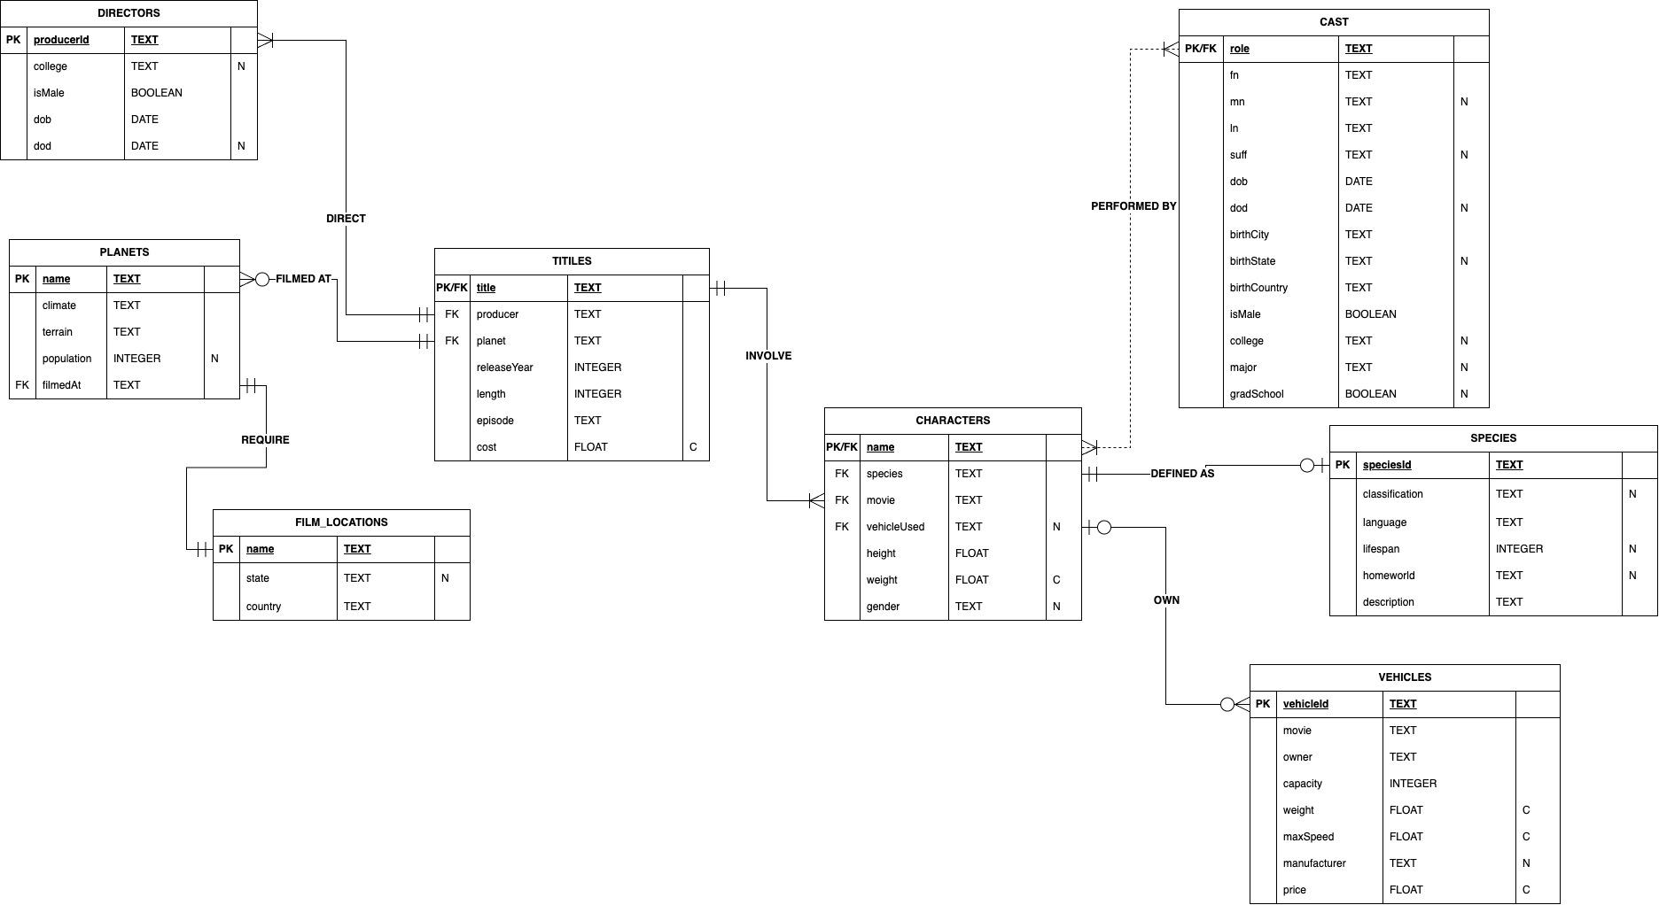

How-to Instructions

1. Run the SQL file in a database management system such as PostgresSQl
2. Ensure the correct search path is being utilized
3. Familiarize yourself with the schema and utilize the ERD and the data dictionary
4. Query the Data to explore the data that has been provided
5. Utilize the functions created to perform specific tasks
6. Implement the triggers to perform separate actions to update the population of planets and update the director count
7. Explore the aggregate functions to your unique needs
8. Feel free to write your own custom queries when needed
9. Modify the schema where fit to extend the functionality of the database
10. Have Fun!!!